DAY – 02 : 90 Days of Devops

Linux Architecture, Processes, and systemd

Task
Today’s goal is to understand how Linux works under the hood.
will create a short note that explains:
- The core components of Linux (kernel, user space, init/systemd)
- How processes are created and managed
- What systemd does and why it matters

This is the foundation for all troubleshooting you will do as a DevOps engineer.

Linux Architecture

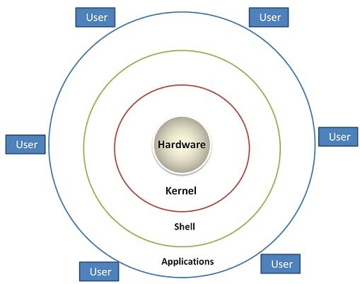

Linux is built in layers, each with a specific role — from hardware control to user interaction.

1. Hardware Layer
- The physical components: CPU, memory, disks, and devices.
- Linux interacts with these through device drivers.
2. Kernel Layer
- The core of Linux — it manages communication between hardware and software.
- Key functions:
  - Process Management – handles creation, scheduling, and termination.
  - Memory Management – allocates and frees memory.
  - Device Management – controls hardware via drivers.
  - File System Management – organizes data into files and directories.
3. System Library Layer
- Provides standard functions (like printf, open, read) that applications use to interact with the kernel.
- Example: glibc (GNU C Library).
4. System Utility Layer
- Contains essential tools for system maintenance and configuration.
- Examples: ls, cp, ps, systemctl.
5. User Layer
- Where users interact with the system through:
  - Shells (e.g., Bash, Zsh)
  - Graphical Interfaces (e.g., GNOME, KDE)
  - Applications (e.g., browsers, editors)

Explanation of the Layers:
- Hardware – The physical components (CPU, memory, storage, devices).
- Kernel – The core of Linux that manages processes, memory, devices, and file systems.
- System Libraries – Provide APIs that let programs talk to the kernel (e.g., glibc).
- System Utilities – Essential tools for system configuration and management.
- User Applications – Shells, GUIs, and programs that users interact with directly.

Core Components of Linux

- Kernel: The heart of the operating system. It manages hardware resources (CPU, memory, devices) and provides system calls for user applications.
- User Space: Where applications and utilities run. This includes shells, graphical environments, and user programs.
- Init/Systemd: The first process started by the kernel after boot. Traditionally init, but now most modern distributions use systemd to initialize and manage services.

How Processes Work

- A process is just a running program.
- Linux creates new processes by copying an existing one (fork) and then loading a new program into it (exec).
- Each process has a unique ID (PID) and is scheduled by the kernel.
- You can manage them with commands like ps, top, kill, or systemctl.

Why Systemd Matters

- It starts services in parallel → faster boot.
- It manages dependencies → ensures things start in the right order.
- It gives you one tool (systemctl) to control services, timers, sockets, and more.
- It integrates logging with journald.

In short: Systemd makes Linux startup and service management smoother, faster, and more consistent.

Simple Analogy
Think of Linux like a car:
- Hardware → Engine, wheels, body
- Kernel → The driver controlling everything
- System Libraries → The dashboard and controls
- Utilities → Tools for maintenance
- User Layer → You, giving commands to drive

